**EM Characterization of MF-RAM**

RCS and NRL Arch Project Proposal

Prepared by Chris Toner, David Eding, Kirk Jungles, Jose Alvarez

PSU Capstone / Wi ‘20

26-Jan-2020

# 

# Table of Contents

**Table of Contents** **1**

**Executive Summary / Concept of Operations** **2**

**Requirements** **2**

**RCS Measurement System Requirements** **3**

**Reflectivity Measurement System Requirements** **3**

**System Architecture** **4**

**RCS Measurement System Architecture** **4**

**RCS System Block Diagram** **5**

**Reflectivity Measurement System Architecture** **6**

**NRL Arch System Block Diagram** **7**

**Project Implementation** **8**

**Timeline** **8**

**Initial Project Backlog** **9**

**Summary** **10**

**References** **10**

# Executive Summary / Concept of Operations

Radar Cross Section is a measure of the effective area of an object under the view of a radar system. It is dependent on a variety of factors, including the geometry of the object under test and the material the object is composed of. Tangitek has developed a material that can be placed on the exterior of various objects that would decrease their effective RCS and reflectivity without making alterations to their surface area and geometry, thereby reducing their visibility on radar systems.

Our project is the development of an automated measurement system for determining the monostatic(receiver and transmitter at the same location) RCS and reflectivity of various microwave absorbing materials provided to us by TangiTek. The measurements will be performed within the confines of Portland State University’s [RF chamber](http://psu-epl.github.io/doc/equip/testing/RF-Chamber) and it will be composed of an RCS measurement system and an NRL Arch setup for reflectivity measurements.

The RCS portion will be composed of a VNA and a transmitting horn antenna mounted on a stand that transmits continuous signals in the 2-40 GHz range, a turntable to rotate the object under test on the opposite side of the room from the antenna, a receiving horn antenna to catch the backscattered signals and feed back into the VNA, and a computer connected both to the VNA and turntable to automate the measurement process.

The NRL Arch setup will be composed of a portable arch, a pair of opposing horn antennas, a mechanism by which the horn antennas can move about the arch, a turntable to rotate the object under test, and a VNA operating in the 2-40 GHz range.

# Requirements

In the most basic sense, we seek to provide TangiTek with a well-documented means of measuring both RCS and freespace reflectivity of new materials that they need characterized. We have broken down both projects into their own set of requirements; one for the RCS measurement system, and one for reflectivity measurement system.

It should be noted here that for both projects, documentation and reproducibility of our work are essential. We will be documenting all of our design decisions, code used, and instructions for use of our measurement system. All completed work not protected under NDA will be documented and posted on our public Github repository primarily for use by TangiTek, then for all others who wish to develop similar systems.

# **RCS Measurement System Requirements**

**MUST**

* Must use resources readily available for use by Tangitek
* Must perform RCS measurements in S-Ku bands (2-18 GHz range)
* Must rotate Object Under Test full 360 degree azimuthal range
* Must automatically sweep frequencies on VNA and gather data organized according to frequency
* Must synthesize data from VNA to get RCS data for full range of frequencies and incident angles
* Must be demonstrated to provide RCS measurements that agree with simulations within 15%
  + Performance will be verified by comparing measured vs simulated values of a copper sphere

**MAY**

* May perform RCS measurements in K-Ka bands (18-40 GHz range)
* May use software for noise cancellation after measurements
* May use hardware for noise cancellation during measurements
* May collect data on RCS measurements at varying zenith angles of incidence
* May use weird objects like mannequins and drones to perform measurements

# **Reflectivity Measurement System Requirements**

**MUST**

* Must use resources readily available for use by Tangitek
* Must perform NRL Arch reflectivity measurements in S-Ku bands (2-18 GHz range)
* Must include NRL Arch that:
  + Has antennas that can be easily repositioned to knowable desired angle of transmission/reflection
  + Can be transported into and out of PSU’s RF chamber with relative simplicity
  + Is physically sturdy and reliable
  + Is composed of materials offering minimal interference with measurements
* Must rotate Object Under Test full 360 degree azimuthal range
* Must automatically sweep frequencies on VNA and gather data organized according to frequency
* Must synthesize data from VNA to get reflectivity data for full range of frequencies and incident angles
* Must be able to keep measured reflectivity values agree within 10% for repeated experiments after taking down and setting up system again

**MAY**

* May perform reflectivity measurements in K-Ka bands (18-40 GHz range)
* May use software for noise cancellation after measurements
* May use hardware for noise cancellation during measurements
* May incorporate into the NRL Arch design:
  + Smaller submodules for improved portability
  + Method for adjusting distances between Object Under Test and antennae
  + Track car system for moving antennae with ease composed of:
    - A small wooden track car for antennae that can move freely within the track but lock into place at the desired angles
    - A spring-loaded stopper that can be inserted into the antenna track at the desired angle and lock into place
    - A clamp and locking system on the track car that will hold the antennae into place pointed radially inward

# System Architecture

For the system architecture we are planning to have both measurement systems designed for use in PSU’s anechoic chamber for low noise and farfield behavior. Again, we have broken up the measurement systems into two separate sections, RCS and Reflectivity respectively.

# **RCS Measurement System Architecture**

For our RCS system, we will have a VNA capable of 2-40 GHz frequency transmission injecting signals into a transmission horn antenna corresponding to the frequency band being tested. The signal will then propagate towards the target, which will be approximately 5 meters away from the transmission antenna. The reflected signal will then travel to an identical receiving horn antenna, which will feed back into the VNA. A duplexer may be inserted between the VNA and horn antennas.

The target will be resting on a turntable, which will rotate the full 360 degree azimuthal range. The turn table may be controlled manually, or it may be controlled using software, depending on what progress we make in improving the turntable’s capabilities. If the turntable can be made to operate effectively by software, it will be controlled by a computer through fiber optical signals.

During measurement, the computer will communicate with the VNA through GPIB interface, and possibly with the turntable through the optoconverter. The measurement procedure for both operations will be implemented in MATLAB. The procedure will write an initial desired turntable angle for measurement, transmit and receive signals in a range of frequencies allowed by the antennas in use, record data for all frequencies at that angle, increment the turntable angle by 5 degrees, and repeat frequency scanning and data collection for all angles.

After measurements for all desired angles and for each set of frequencies is complete, a post-measurement processing script will convert raw received power data into RCS values as a function of object angle and frequency.

## RCS System Block Diagram

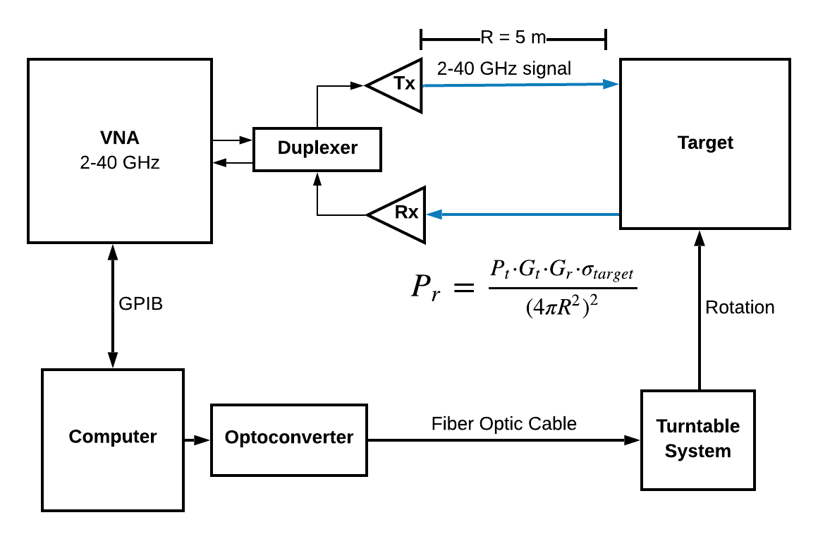

Figure : RCS System block diagram

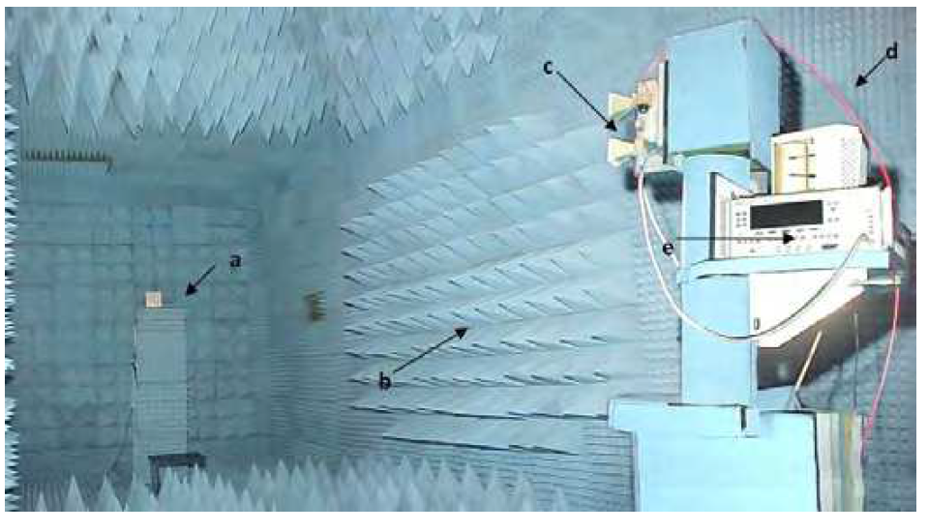

Figure : Similar Experimental Setup for RCS system

# **Reflectivity Measurement System Architecture**

For our NRL Arch Reflectivity Measurement System, we will have an NRL Arch style arch that supports a pair of opposing antennas at varying zenith angles. The exact support and placement mechanism of the antennae has not yet been determined, but will likely be composed of a track car system that rolls along the arch at user-specified angles.

At all angles of incidence of the pairs of antenna, a 2-40 GHz VNA will inject signals into the transmitting antenna, which will then propagate towards a flat target at the center of the arch. The reflected signals will then be received by an identical receiving antenna and fed back into the VNA.

The target will be resting on a turntable, which will rotate the full 360 degree azimuthal range. The turn table may be controlled manually, or it may be controlled using software, depending on what progress we make in improving the turntable’s capabilities. If the turntable can be made to operate effectively by software, it will be controlled by a computer through fiber optical signals.

During measurement, the computer will communicate with the VNA through GPIB interface, and possibly with the turntable through the optoconverter. The measurement procedure for both operations will be implemented in MATLAB. The procedure will write an initial desired turntable angle for measurement, transmit and receive signals in a range of frequencies allowed by the antennas in use, record data for all frequencies at that angle, increment the turntable angle by 5 degrees, and repeat frequency scanning and data collection for all angles.

After measurements for all desired angles and for each set of frequencies is complete, a post-measurement processing script will convert raw received power data into NRL Arch reflectivity values as a function of object angle and frequency.

## NRL Arch System Block Diagram

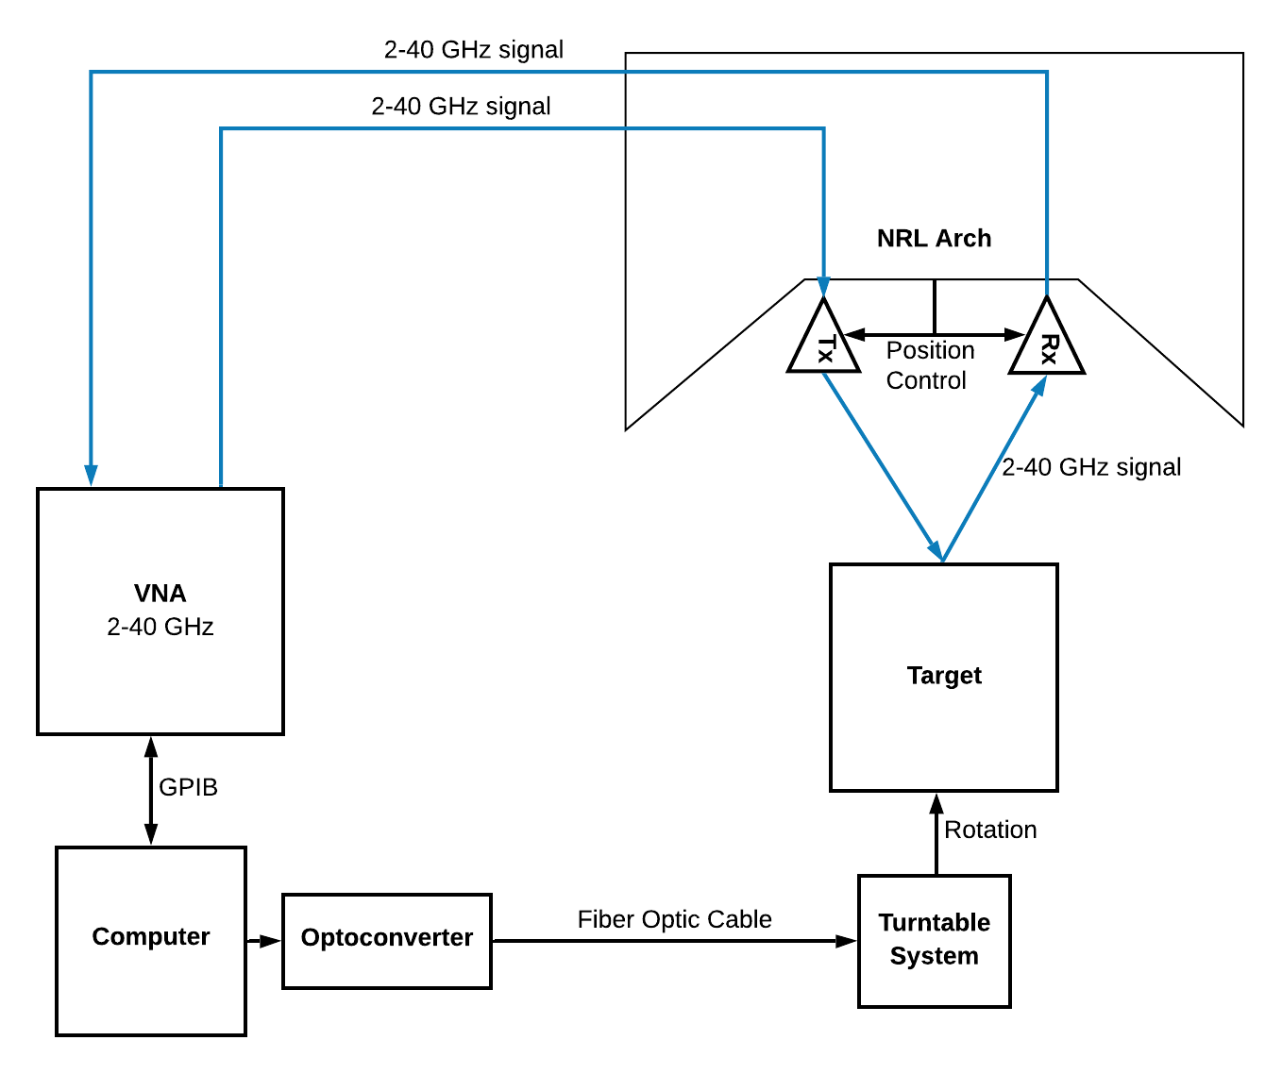

Figure : NRL Arch Measurement System Block Diagram

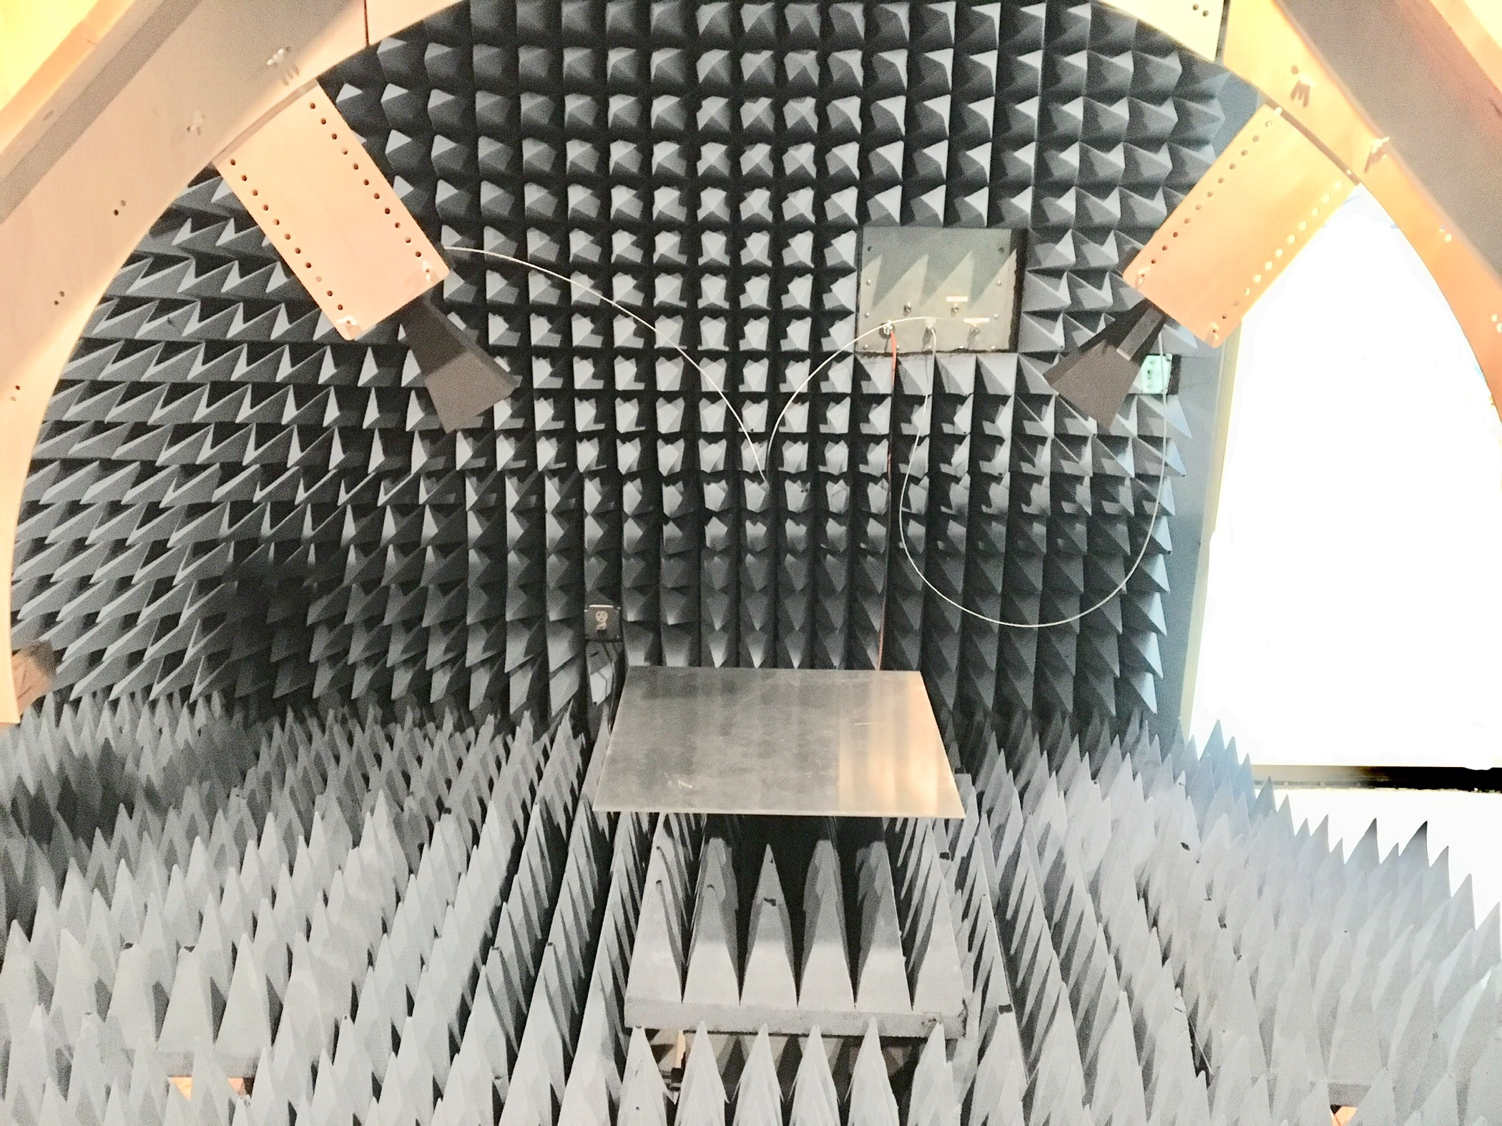

Figure : Similar Experimental Setup for NRL Arch System

# Project Implementation

For the entirety of our project, we will be using SCRUM methodology in conjunction with Trello to stay organized. We will be meeting in person every Friday to discuss our progress in detail and go over technical issues. Every other Friday we will have Sprint Retrospective, Review, and Planning meetings. We will also be having standups on Tuesdays in person and on Sundays via Google Hangouts. We will be communicating constantly on our Slack channel and we will be using Github for version control for all code and project documentation. Kirk will be performing as SCRUM master, but all team decisions will be made democratically.

# **Timeline**

Our timeline is described using the Gantt chart that follows. With our current estimates for the amount of time it takes for each task, we will have our project completed in April. In reality, our project will take longer, so we expect to use most, if not all, of the cushion available to us.

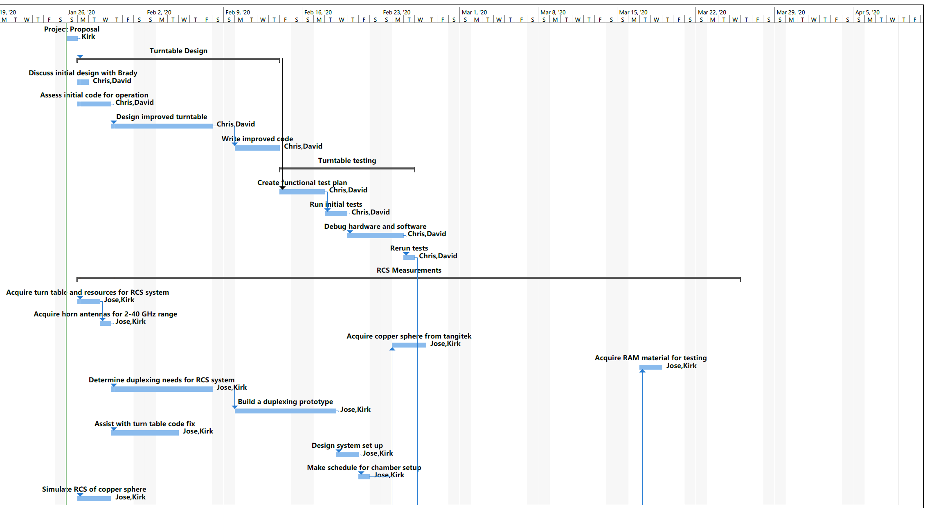

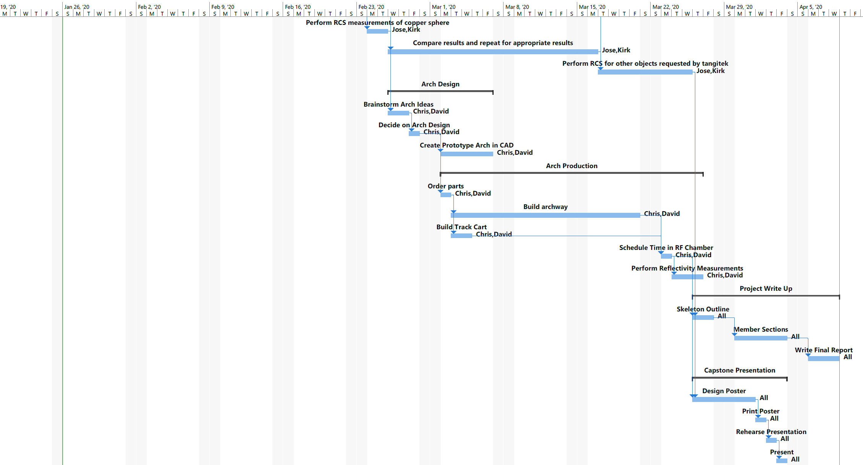

Figure : Gantt Chart for project completion

# **Initial Project Backlog**

Our initial project backlog is broken down into over 40 unique tasks, each with their own subtasks as checklists in Trello. For brevity, we will summarize our tasks as:

* Turntable Design
* Turntable Testing
* RCS Measurement Design
* RCS Measurement Testing
* NRL Arch Design
* NRL Arch Production
* NRL Arch Testing
* Project Report Writing
* Project Poster Presentation

Some of these task summaries will be worked on in parallel, with David Eding and Chris Toner working primarily on NRL Arch and turntable related tasks, while Kirk Jungles and Jose Alvarez will be focusing on the RCS system.

# Summary

In short, our project is the design, build, and testing of a comprehensive measurement suite that will provide both RCS and NRL Arch reflectivity measurements to TangiTek for testing of the materials they develop. Our deliverable will not only be measurements of materials provided, but more importantly, a well-documented system that TangiTek can use as needed. All resources used in the project will be available for repeated use by TangiTek, and our documentation will ensure that their use of our system won’t prove to be too challenging.

# References

1. G. Martin. Measurement of Radar Cross Section Using the “VNA Master” Handheld VNA. Anritsu Application Note.
2. M. A. S. Miacci, M. C. Rezende. Basics on Radar Cross Section Reduction Measurements of Simple and Complex Targets Using Microwave Absorbers. Applied Measurement Systems.
3. V.G. Borkar*, A. Ghosh, R.K. Singh, and N. Chourasia. Radar Cross-section Measurement Techniques. Defence Science Journal, Vol. 60, No. 2, March 2010, pp. 204-212
4. Prototypical NRL Arch Design. <http://masttechnologies.com/wp-content/uploads/2012/01/Tech-Bulletin-101-NRL-Arch-Reflectivity.pdf>
5. Capstone Project Description. <http://web.cecs.pdx.edu/~faustm/capstone/projectdescriptions/2020/e2e6dbe3-4360-4b40-8381-48b16979ca49/PSU-CapStoneProject-Description-2019.pdf>
6. Background on Nicolson-Ross-Weir method. <https://www.mdpi.com/2079-9292/6/4/95/htm>
7. Research on RAM Characterization via the NRL Arch Tool method. <https://www.researchgate.net/publication/3951816_Electromagnetic_behavior_of_radar_absorbing_materials_based_on_conducting_polymers#pf2>
8. Costa, F.; Borgese, M.; Degiorgi, M.; Monorchio, A. Electromagnetic Characterisation of Materials by Using Transmission/Reflection (T/R) Devices. *Electronics* **2017**, *6*, 95.
9. Dixon, Paul. “Theory and Application of RF/Microwave Absorbers.” *Emerson & Cuming Microwave Products*.

#### *Mwilab.Com*, 2020, http://www.mwilab.com/services.html#MWI_Arch36. Accessed 27 Jan 2020.

1. Levcheva, Valda P.; Arestova, Iliyana I.; Nikolov, Biser R.; Dankov, Plamen I. “Characterization and Modeling of Microwave Absorbers in the RF and Antenna Projects.” *Telfor Journal* **2009,** *1*, 2.
2. Le, Thanh; Tran, Ha; Pejcinovic, Branimir; Thompson, Kent G.R.; Doneker, Robert; Ramachandran, Adithya. “Development and Characterization of Carbon-Fiber Based Magnetically Loaded Microwave Absorber Material.” *Proc. of the 2018 International Symposium on Electromagnetic Compatibility (EMC Europe 2018)*, Amsterdam, The Netherlands. Aug. 27-30, 2018.